**PROJECT REPORT**

*Web Engineering Lab (SEL-310)*



**PROJECT TITLE:**

[Customer Relationship Management (CRM) System](http://localhost:8000/dashboard.php)

**BS(CS)-6A**

*Group Members*

|  |  |
| --- | --- |
| **Name** | **Enrollment** |
| 1.Sheikh Muhammad Saad | **02-134202-069** |
| 2.Arqam Wadiwala | **02-134202-085** |
| 3.Muhammad Rana Shamas | **02-134202-076** |

**Submitted to:**

**Engr.Ambreen Akram**

**BAHRIA UNIVERSITY KARACHI CAMPUS**

*Department of Computer Science*

Table of Contents

2 Introduction 3

3 Objectives 3

4 Problem Statement 4

5 Methodology 4

6 Code 4

6.1 Contact.php 4

6.2 Customer.php 12

6.3 Leads.php 19

6.4 Opportunity.php 27

6.5 Tasks.php 34

6.6 USER.php 40

6.7 Config->database.php 48

6.8 Crm-system.sql 49

6.9 Header4.php 55

6.10 Contact_action.php 56

6.11 Contact.php 58

6.12 Dashboard.php 63

6.13 Index.php 66

6.14 Leftmenus.php 69

6.15 Manageraction.php 70

6.16 Top_menus.php 72

6.17 Sales_people.php 73

7 Outputs 78

7.1 FOR SALES MANAGER 78

7.2 FOR SALESPERSON 81

# Introduction

The project customer relationship management system will make ease for customers as well as the business/company owners. The system will help the customer to know the status of their product/services. It will also show the business owner about any changes and payments etc made by the customers. The project will contain:

Home Page:

When browsing the website, the visitor will be redirected to this page by default. The person can choose if he is customer or the administrator (owner of business)

Login Page:

The person can log in using their credentials from this page.

# Objectives

1. To effectively manage and organize customer data for improved customer interactions and relationships.
2. To streamline sales and marketing processes by providing a centralized platform for tracking leads, contacts, and opportunities.
3. To enhance customer service by enabling quick access to customer information and history.
4. To generate comprehensive reports and analytics for informed decision-making.
5. To increase efficiency and productivity by automating repetitive tasks and workflows.
6. To ensure data security and privacy by implementing appropriate access controls and encryption measures.

# Problem Statement

The existing manual customer management processes lack efficiency, resulting in disorganized customer data and a disjointed customer experience. The absence of a centralized system leads to difficulties in tracking leads, managing interactions, and generating accurate reports. This inefficiency hampers productivity and customer satisfaction, which in turn affects business growth and profitability. Therefore, there is a need for a robust CRM system to address these challenges and streamline customer relationship management processes.

# Methodology

Understanding Requirements: Gather information about what the CRM system needs to do. The options and requirements it should have. Also what features should be present in the project.

Planning the Design: Create a rough draft for how the CRM system will look and work, including the layout, database structure, and how users will interact with it.

Building the System: Use PHP and HTML to develop the CRM system according to the design plan. We made sure to use best security practices .

Running it on Xampp: When all necessary php , html and css files were made , we ran the project on xampp to check if it was working fine. We checked all features.

Deployment on a free domain: As an extra added feature, we got a free domain and deployed our project on a domain which can be accesible on any device anywhere. We did necessary changes in Config files and databases to meet the website requirements. MYSQLI was also mantained to work perfectly online.   
The website can be accessed on this URL:- [**http://webassignment.unaux.com/**](http://webassignment.unaux.com/)

# Code

## Contact.php

<?php

class Contact {

private $userTable = 'crm_users';

private $contactTable = 'crm_contact';

private $tasksTable = 'crm_tasks';

private $conn;

public function __construct($db){

$this->conn = $db;

}

public function listContact(){

$sqlWhere = '';

if($_SESSION["role"] == 'sales') {

$sqlWhere = " WHERE c.sales_rep = '".$_SESSION["userid"]."'";

}

$sqlQuery = "SELECT c.id, c.contact_first, c.company, c.industry, c.budget, u.name

FROM ".$this->contactTable." c

LEFT JOIN ".$this->userTable." u ON c.sales_rep = u.id $sqlWhere";

if(!empty($_POST["order"])){

$sqlQuery .= ' ORDER BY '.$_POST['order']['0']['column'].' '.$_POST['order']['0']['dir'].' ';

} else {

$sqlQuery .= ' ORDER BY id ASC ';

}

if($_POST["length"] != -1){

$sqlQuery .= 'LIMIT ' . $_POST['start'] . ', ' . $_POST['length'];

}

$stmt = $this->conn->prepare($sqlQuery);

$stmt->execute();

$result = $stmt->get_result();

$stmtTotal = $this->conn->prepare("SELECT * FROM ".$this->contactTable);

$stmtTotal->execute();

$allResult = $stmtTotal->get_result();

$allRecords = $allResult->num_rows;

$displayRecords = $result->num_rows;

$records = array();

while ($contact = $result->fetch_assoc()) {

$rows = array();

$rows[] = $contact['id'];

$rows[] = ucfirst($contact['contact_first']);

$rows[] = $contact['company'];

$rows[] = $contact['industry'];

$rows[] = $contact['budget'];

$rows[] = $contact['name'];

$rows[] = '<button type="button" name="view" id="'.$contact["id"].'" class="btn btn-info btn-xs view"><span title="View Tasks">View Tasks</span></button>';

$rows[] = '<button type="button" name="update" id="'.$contact["id"].'" class="btn btn-warning btn-xs update"><span class="glyphicon glyphicon-edit" title="Edit">Edit</span></button>';

$rows[] = '<button type="button" name="delete" id="'.$contact["id"].'" class="btn btn-danger btn-xs delete" ><span class="glyphicon glyphicon-remove" title="Delete">Delete</span></button>';

$records[] = $rows;

}

$output = array(

"draw" => intval($_POST["draw"]),

"iTotalRecords" => $displayRecords,

"iTotalDisplayRecords" => $allRecords,

"data" => $records

);

echo json_encode($output);

}

public function insert(){

if($this->contact_first) {

$stmt = $this->conn->prepare("

INSERT INTO ".$this->contactTable."(`contact_first`, `contact_last`, `company`, `industry`, `budget`, `sales_rep`)

VALUES(?,?,?,?,?,?)");

$this->contact_first = htmlspecialchars(strip_tags($this->contact_first));

$this->contact_last = htmlspecialchars(strip_tags($this->contact_last));

$this->contact_company = htmlspecialchars(strip_tags($this->contact_company));

$this->contact_industry = htmlspecialchars(strip_tags($this->contact_industry));

$this->contact_budget = htmlspecialchars(strip_tags($this->contact_budget));

$this->contact_sales_rep = htmlspecialchars(strip_tags($this->contact_sales_rep));

$stmt->bind_param("ssssii", $this->contact_first, $this->contact_last, $this->contact_company, $this->contact_industry, $this->contact_budget, $this->contact_sales_rep);

if($stmt->execute()){

return true;

}

}

}

public function getContact(){

if($this->contact_id) {

$sqlQuery = "

SELECT c.id, c.contact_first, c.contact_last, c.company, c.industry, c.budget, u.id as sale_rep_id, u.name

FROM ".$this->contactTable." c

LEFT JOIN ".$this->userTable." u ON c.sales_rep = u.id

WHERE c.id = ?";

$stmt = $this->conn->prepare($sqlQuery);

$stmt->bind_param("i", $this->contact_id);

$stmt->execute();

$result = $stmt->get_result();

$record = $result->fetch_assoc();

echo json_encode($record);

}

}

public function update(){

if($this->contact_id) {

$stmt = $this->conn->prepare("

UPDATE ".$this->contactTable."

SET contact_first = ?, contact_last = ?, company = ?, industry = ?, budget = ?, sales_rep = ?

WHERE id = ?");

$this->contact_first = htmlspecialchars(strip_tags($this->contact_first));

$this->contact_last = htmlspecialchars(strip_tags($this->contact_last));

$this->contact_company = htmlspecialchars(strip_tags($this->contact_company));

$this->contact_industry = htmlspecialchars(strip_tags($this->contact_industry));

$this->contact_budget = htmlspecialchars(strip_tags($this->contact_budget));

$this->contact_sales_rep = htmlspecialchars(strip_tags($this->contact_sales_rep));

$stmt->bind_param("ssssiii", $this->contact_first, $this->contact_last, $this->contact_company, $this->contact_industry, $this->contact_budget, $this->contact_sales_rep, $this->contact_id);

if($stmt->execute()){

return true;

}

}

}

public function delete(){

if($this->contact_id) {

$stmt = $this->conn->prepare("

DELETE FROM ".$this->contactTable."

WHERE id = ?");

$this->contact_id = htmlspecialchars(strip_tags($this->contact_id));

$stmt->bind_param("i", $this->contact_id);

if($stmt->execute()){

return true;

}

}

}

public function getTasks(){

if($this->contact_id) {

$sqlQuery = "SELECT t.id, t.created, t.task_type, t.task_description, t.task_due_date, t.task_status, t.task_update, c.contact_first, u.name

FROM ".$this->tasksTable." t

LEFT JOIN ".$this->contactTable." c ON t.contact = c.id

LEFT JOIN ".$this->userTable." u ON t.sales_rep = u.id

WHERE t.contact = ?";

$stmt = $this->conn->prepare($sqlQuery);

$stmt->bind_param("i", $this->contact_id);

$stmt->execute();

$result = $stmt->get_result();

$records = array();

while ($tasks = $result->fetch_assoc()) {

$rows = array();

$rows[] = $tasks['id'];

$rows[] = $tasks['created'];

$rows[] = $tasks['task_type'];

$rows[] = $tasks['task_description'];

$rows[] = $tasks['task_due_date'];

$rows[] = $tasks['task_status'];

$rows[] = $tasks['contact_first'];

$rows[] = $tasks['name'];

$records[] = $rows;

}

$output = array(

"data" => $records

);

echo json_encode($output);

}

}

}

?>

## Customer.php

<?php

class Customer {

private $userTable = 'crm_users';

private $contactTable = 'crm_contact';

private $tasksTable = 'crm_tasks';

private $conn;

public function __construct($db){

$this->conn = $db;

}

public function listOpportunity(){

$sqlWhere = '';

if($_SESSION["role"] == 'sales') {

$sqlWhere = " WHERE c.sales_rep = '".$_SESSION["userid"]."' and c.status = 'Customer / won'";

}

$sqlQuery = "SELECT c.id, c.contact_first, c.company, c.industry, c.budget, u.name, c.phone, c.website, c.status, c.initial_contact_date, c.email

FROM ".$this->contactTable." c

LEFT JOIN ".$this->userTable." u ON c.sales_rep = u.id $sqlWhere";

if(!empty($_POST["order"])){

$sqlQuery .= ' ORDER BY '.$_POST['order']['0']['column'].' '.$_POST['order']['0']['dir'].' ';

} else {

$sqlQuery .= ' ORDER BY id ASC ';

}

if($_POST["length"] != -1){

$sqlQuery .= 'LIMIT ' . $_POST['start'] . ', ' . $_POST['length'];

}

$stmt = $this->conn->prepare($sqlQuery);

$stmt->execute();

$result = $stmt->get_result();

$stmtTotal = $this->conn->prepare("SELECT * FROM ".$this->contactTable);

$stmtTotal->execute();

$allResult = $stmtTotal->get_result();

$allRecords = $allResult->num_rows;

$displayRecords = $result->num_rows;

$records = array();

while ($contact = $result->fetch_assoc()) {

$rows = array();

$rows[] = $contact['id'];

$rows[] = ucfirst($contact['contact_first']);

$rows[] = $contact['company'];

$rows[] = $contact['industry'];

$rows[] = $contact['phone'];

$rows[] = $contact['email'];

$rows[] = $contact['website'];

$rows[] = '<button type="button" name="view" id="'.$contact["id"].'" class="btn btn-info btn-xs view"><span title="View Tasks">View Notes</span></button>';

$rows[] = '<button type="button" name="update" id="'.$contact["id"].'" class="btn btn-warning btn-xs update"><span class="glyphicon glyphicon-edit" title="Edit">Edit</span></button>';

$rows[] = '<button type="button" name="delete" id="'.$contact["id"].'" class="btn btn-danger btn-xs delete" ><span class="glyphicon glyphicon-remove" title="Delete">Delete</span></button>';

$records[] = $rows;

}

$output = array(

"draw" => intval($_POST["draw"]),

"iTotalRecords" => $displayRecords,

"iTotalDisplayRecords" => $allRecords,

"data" => $records

);

echo json_encode($output);

}

public function insert(){

if($this->lead_first) {

$stmt = $this->conn->prepare("

INSERT INTO ".$this->contactTable."(`contact_first`, `contact_last`, `company`, `industry`, `budget`, `sales_rep`, `phone`, `email`, `website`, `status`)

VALUES(?,?,?,?,?,?,?,?,?,?)");

$this->lead_first = htmlspecialchars(strip_tags($this->lead_first));

$this->lead_last = htmlspecialchars(strip_tags($this->lead_last));

$this->lead_company = htmlspecialchars(strip_tags($this->lead_company));

$this->lead_industry = htmlspecialchars(strip_tags($this->lead_industry));

$this->lead_budget = htmlspecialchars(strip_tags($this->lead_budget));

$this->lead_status = htmlspecialchars(strip_tags($this->lead_status));

$this->lead_email = htmlspecialchars(strip_tags($this->lead_email));

$this->lead_phone = htmlspecialchars(strip_tags($this->lead_phone));

$this->lead_website = htmlspecialchars(strip_tags($this->lead_website));

$stmt->bind_param("ssssiiisss", $this->lead_first, $this->lead_last, $this->lead_company, $this->lead_industry, $this->lead_budget, $_SESSION["userid"], $this->lead_phone, $this->lead_email, $this->lead_website, $this->lead_status);

if($stmt->execute()){

return true;

}

}

}

public function getLead(){

if($this->id) {

$sqlQuery = "

SELECT c.id, c.contact_first, c.contact_last, c.company, c.industry, c.budget, u.id as sale_rep_id, u.name, c.phone, c.website, c.status, c.initial_contact_date, c.email

FROM ".$this->contactTable." c

LEFT JOIN ".$this->userTable." u ON c.sales_rep = u.id

WHERE c.id = ?";

$stmt = $this->conn->prepare($sqlQuery);

$stmt->bind_param("i", $this->id);

$stmt->execute();

$result = $stmt->get_result();

$record = $result->fetch_assoc();

echo json_encode($record);

}

}

public function update(){

if($this->id) {

$stmt = $this->conn->prepare("

UPDATE ".$this->contactTable."

SET contact_first = ?, contact_last = ?, company = ?, industry = ?, budget = ?, sales_rep = ?, phone = ?, email = ?, website = ?, status = ?

WHERE id = ?");

$this->lead_first = htmlspecialchars(strip_tags($this->lead_first));

$this->lead_last = htmlspecialchars(strip_tags($this->lead_last));

$this->lead_company = htmlspecialchars(strip_tags($this->lead_company));

$this->lead_industry = htmlspecialchars(strip_tags($this->lead_industry));

$this->lead_budget = htmlspecialchars(strip_tags($this->lead_budget));

$this->lead_status = htmlspecialchars(strip_tags($this->lead_status));

$this->lead_email = htmlspecialchars(strip_tags($this->lead_email));

$this->lead_phone = htmlspecialchars(strip_tags($this->lead_phone));

$this->lead_website = htmlspecialchars(strip_tags($this->lead_website));

$stmt->bind_param("ssssiiisssi", $this->lead_first, $this->lead_last, $this->lead_company, $this->lead_industry, $this->contact_budget, $_SESSION["userid"], $this->lead_phone, $this->lead_email, $this->lead_website, $this->lead_status, $this->id);

if($stmt->execute()){

return true;

}

}

}

public function delete(){

if($this->id) {

$stmt = $this->conn->prepare("

DELETE FROM ".$this->contactTable."

WHERE id = ?");

$this->id = htmlspecialchars(strip_tags($this->id));

$stmt->bind_param("i", $this->id);

if($stmt->execute()){

return true;

}

}

}

public function getOpportunityDetails(){

if($this->id) {

$sqlQuery = "SELECT t.id, t.created, t.task_type, t.task_description, t.task_due_date, t.task_status, t.task_update, c.contact_first, u.name

FROM ".$this->tasksTable." t

LEFT JOIN ".$this->contactTable." c ON t.contact = c.id

LEFT JOIN ".$this->userTable." u ON t.sales_rep = u.id

WHERE t.contact = ?";

$stmt = $this->conn->prepare($sqlQuery);

$stmt->bind_param("i", $this->id);

$stmt->execute();

$result = $stmt->get_result();

$records = array();

while ($tasks = $result->fetch_assoc()) {

$rows = array();

$rows[] = $tasks['id'];

$rows[] = $tasks['created'];

$rows[] = $tasks['task_type'];

$rows[] = $tasks['task_description'];

$rows[] = $tasks['task_due_date'];

$rows[] = $tasks['task_status'];

$rows[] = $tasks['contact_first'];

$rows[] = $tasks['name'];

$records[] = $rows;

}

$output = array(

"data" => $records

);

echo json_encode($output);

}

}

}

?>

## Leads.php

<?php

class Leads {

private $userTable = 'crm_users';

private $contactTable = 'crm_contact';

private $tasksTable = 'crm_tasks';

private $conn;

public function __construct($db){

$this->conn = $db;

}

public function listLeads(){

$sqlWhere = '';

if($_SESSION["role"] == 'sales') {

$sqlWhere = " WHERE c.sales_rep = '".$_SESSION["userid"]."' and c.status = 'Lead'";

}

$sqlQuery = "SELECT c.id, c.contact_first, c.company, c.industry, c.budget, u.name, c.phone, c.website, c.status, c.initial_contact_date, c.email

FROM ".$this->contactTable." c

LEFT JOIN ".$this->userTable." u ON c.sales_rep = u.id $sqlWhere";

if(!empty($_POST["order"])){

$sqlQuery .= ' ORDER BY '.$_POST['order']['0']['column'].' '.$_POST['order']['0']['dir'].' ';

} else {

$sqlQuery .= ' ORDER BY id ASC ';

}

if($_POST["length"] != -1){

$sqlQuery .= 'LIMIT ' . $_POST['start'] . ', ' . $_POST['length'];

}

$stmt = $this->conn->prepare($sqlQuery);

$stmt->execute();

$result = $stmt->get_result();

$stmtTotal = $this->conn->prepare("SELECT * FROM ".$this->contactTable);

$stmtTotal->execute();

$allResult = $stmtTotal->get_result();

$allRecords = $allResult->num_rows;

$displayRecords = $result->num_rows;

$records = array();

while ($contact = $result->fetch_assoc()) {

$rows = array();

$rows[] = $contact['id'];

$rows[] = ucfirst($contact['contact_first']);

$rows[] = $contact['company'];

$rows[] = $contact['industry'];

$rows[] = $contact['phone'];

$rows[] = $contact['email'];

$rows[] = $contact['website'];

$rows[] = $contact['status'];

$rows[] = $contact['initial_contact_date'];

$rows[] = '<button type="button" name="view" id="'.$contact["id"].'" class="btn btn-info btn-xs view"><span title="View Tasks">View Notes</span></button>';

$rows[] = '<button type="button" name="update" id="'.$contact["id"].'" class="btn btn-warning btn-xs update"><span class="glyphicon glyphicon-edit" title="Edit">Edit</span></button>';

$rows[] = '<button type="button" name="delete" id="'.$contact["id"].'" class="btn btn-danger btn-xs delete" ><span class="glyphicon glyphicon-remove" title="Delete">Delete</span></button>';

$records[] = $rows;

}

$output = array(

"draw" => intval($_POST["draw"]),

"iTotalRecords" => $displayRecords,

"iTotalDisplayRecords" => $allRecords,

"data" => $records

);

echo json_encode($output);

}

public function insert(){

if($this->lead_first) {

$stmt = $this->conn->prepare("

INSERT INTO ".$this->contactTable."(`contact_first`, `contact_last`, `company`, `industry`, `budget`, `sales_rep`, `phone`, `email`, `website`, `status`)

VALUES(?,?,?,?,?,?,?,?,?,?)");

$this->lead_first = htmlspecialchars(strip_tags($this->lead_first));

$this->lead_last = htmlspecialchars(strip_tags($this->lead_last));

$this->lead_company = htmlspecialchars(strip_tags($this->lead_company));

$this->lead_industry = htmlspecialchars(strip_tags($this->lead_industry));

$this->lead_budget = htmlspecialchars(strip_tags($this->lead_budget));

$this->lead_status = htmlspecialchars(strip_tags($this->lead_status));

$this->lead_email = htmlspecialchars(strip_tags($this->lead_email));

$this->lead_phone = htmlspecialchars(strip_tags($this->lead_phone));

$this->lead_website = htmlspecialchars(strip_tags($this->lead_website));

$stmt->bind_param("ssssiiisss", $this->lead_first, $this->lead_last, $this->lead_company, $this->lead_industry, $this->lead_budget, $_SESSION["userid"], $this->lead_phone, $this->lead_email, $this->lead_website, $this->lead_status);

if($stmt->execute()){

return true;

}

}

}

public function getLead(){

if($this->id) {

$sqlQuery = "

SELECT c.id, c.contact_first, c.contact_last, c.company, c.industry, c.budget, u.id as sale_rep_id, u.name, c.phone, c.website, c.status, c.initial_contact_date, c.email

FROM ".$this->contactTable." c

LEFT JOIN ".$this->userTable." u ON c.sales_rep = u.id

WHERE c.id = ?";

$stmt = $this->conn->prepare($sqlQuery);

$stmt->bind_param("i", $this->id);

$stmt->execute();

$result = $stmt->get_result();

$record = $result->fetch_assoc();

echo json_encode($record);

}

}

public function update(){

if($this->id) {

$stmt = $this->conn->prepare("

UPDATE ".$this->contactTable."

SET contact_first = ?, contact_last = ?, company = ?, industry = ?, budget = ?, sales_rep = ?, phone = ?, email = ?, website = ?, status = ?

WHERE id = ?");

$this->lead_first = htmlspecialchars(strip_tags($this->lead_first));

$this->lead_last = htmlspecialchars(strip_tags($this->lead_last));

$this->lead_company = htmlspecialchars(strip_tags($this->lead_company));

$this->lead_industry = htmlspecialchars(strip_tags($this->lead_industry));

$this->lead_budget = htmlspecialchars(strip_tags($this->lead_budget));

$this->lead_status = htmlspecialchars(strip_tags($this->lead_status));

$this->lead_email = htmlspecialchars(strip_tags($this->lead_email));

$this->lead_phone = htmlspecialchars(strip_tags($this->lead_phone));

$this->lead_website = htmlspecialchars(strip_tags($this->lead_website));

$stmt->bind_param("ssssiiisssi", $this->lead_first, $this->lead_last, $this->lead_company, $this->lead_industry, $this->contact_budget, $_SESSION["userid"], $this->lead_phone, $this->lead_email, $this->lead_website, $this->lead_status, $this->id);

if($stmt->execute()){

return true;

}

}

}

public function delete(){

if($this->id) {

$stmt = $this->conn->prepare("

DELETE FROM ".$this->contactTable."

WHERE id = ?");

$this->id = htmlspecialchars(strip_tags($this->id));

$stmt->bind_param("i", $this->id);

if($stmt->execute()){

return true;

}

}

}

public function getLeadsDetails(){

if($this->id) {

$sqlQuery = "SELECT t.id, t.created, t.task_type, t.task_description, t.task_due_date, t.task_status, t.task_update, c.contact_first, u.name

FROM ".$this->tasksTable." t

LEFT JOIN ".$this->contactTable." c ON t.contact = c.id

LEFT JOIN ".$this->userTable." u ON t.sales_rep = u.id

WHERE t.contact = ?";

$stmt = $this->conn->prepare($sqlQuery);

$stmt->bind_param("i", $this->id);

$stmt->execute();

$result = $stmt->get_result();

$records = array();

while ($tasks = $result->fetch_assoc()) {

$rows = array();

$rows[] = $tasks['id'];

$rows[] = $tasks['created'];

$rows[] = $tasks['task_type'];

$rows[] = $tasks['task_description'];

$rows[] = $tasks['task_due_date'];

$rows[] = $tasks['task_status'];

$rows[] = $tasks['contact_first'];

$rows[] = $tasks['name'];

$records[] = $rows;

}

$output = array(

"data" => $records

);

echo json_encode($output);

}

}

}

?>

## Opportunity.php

<?php

class Opportunity {

private $userTable = 'crm_users';

private $contactTable = 'crm_contact';

private $tasksTable = 'crm_tasks';

private $conn;

public function __construct($db){

$this->conn = $db;

}

public function listOpportunity(){

$sqlWhere = '';

if($_SESSION["role"] == 'sales') {

$sqlWhere = " WHERE c.sales_rep = '".$_SESSION["userid"]."' and c.status = 'Proposal'";

}

$sqlQuery = "SELECT c.id, c.contact_first, c.company, c.industry, c.budget, u.name, c.phone, c.website, c.status, c.initial_contact_date, c.email

FROM ".$this->contactTable." c

LEFT JOIN ".$this->userTable." u ON c.sales_rep = u.id $sqlWhere";

if(!empty($_POST["order"])){

$sqlQuery .= ' ORDER BY '.$_POST['order']['0']['column'].' '.$_POST['order']['0']['dir'].' ';

} else {

$sqlQuery .= ' ORDER BY id ASC ';

}

if($_POST["length"] != -1){

$sqlQuery .= 'LIMIT ' . $_POST['start'] . ', ' . $_POST['length'];

}

$stmt = $this->conn->prepare($sqlQuery);

$stmt->execute();

$result = $stmt->get_result();

$stmtTotal = $this->conn->prepare("SELECT * FROM ".$this->contactTable);

$stmtTotal->execute();

$allResult = $stmtTotal->get_result();

$allRecords = $allResult->num_rows;

$displayRecords = $result->num_rows;

$records = array();

while ($contact = $result->fetch_assoc()) {

$rows = array();

$rows[] = $contact['id'];

$rows[] = ucfirst($contact['contact_first']);

$rows[] = $contact['company'];

$rows[] = $contact['industry'];

$rows[] = $contact['phone'];

$rows[] = $contact['email'];

$rows[] = $contact['website'];

$rows[] = '<button type="button" name="view" id="'.$contact["id"].'" class="btn btn-info btn-xs view"><span title="View Tasks">View Notes</span></button>';

$rows[] = '<button type="button" name="update" id="'.$contact["id"].'" class="btn btn-warning btn-xs update"><span class="glyphicon glyphicon-edit" title="Edit">Edit</span></button>';

$rows[] = '<button type="button" name="delete" id="'.$contact["id"].'" class="btn btn-danger btn-xs delete" ><span class="glyphicon glyphicon-remove" title="Delete">Delete</span></button>';

$records[] = $rows;

}

$output = array(

"draw" => intval($_POST["draw"]),

"iTotalRecords" => $displayRecords,

"iTotalDisplayRecords" => $allRecords,

"data" => $records

);

echo json_encode($output);

}

public function insert(){

if($this->lead_first) {

$stmt = $this->conn->prepare("

INSERT INTO ".$this->contactTable."(`contact_first`, `contact_last`, `company`, `industry`, `budget`, `sales_rep`, `phone`, `email`, `website`, `status`)

VALUES(?,?,?,?,?,?,?,?,?,?)");

$this->lead_first = htmlspecialchars(strip_tags($this->lead_first));

$this->lead_last = htmlspecialchars(strip_tags($this->lead_last));

$this->lead_company = htmlspecialchars(strip_tags($this->lead_company));

$this->lead_industry = htmlspecialchars(strip_tags($this->lead_industry));

$this->lead_budget = htmlspecialchars(strip_tags($this->lead_budget));

$this->lead_status = htmlspecialchars(strip_tags($this->lead_status));

$this->lead_email = htmlspecialchars(strip_tags($this->lead_email));

$this->lead_phone = htmlspecialchars(strip_tags($this->lead_phone));

$this->lead_website = htmlspecialchars(strip_tags($this->lead_website));

$stmt->bind_param("ssssiiisss", $this->lead_first, $this->lead_last, $this->lead_company, $this->lead_industry, $this->lead_budget, $_SESSION["userid"], $this->lead_phone, $this->lead_email, $this->lead_website, $this->lead_status);

if($stmt->execute()){

return true;

}

}

}

public function getLead(){

if($this->id) {

$sqlQuery = "

SELECT c.id, c.contact_first, c.contact_last, c.company, c.industry, c.budget, u.id as sale_rep_id, u.name, c.phone, c.website, c.status, c.initial_contact_date, c.email

FROM ".$this->contactTable." c

LEFT JOIN ".$this->userTable." u ON c.sales_rep = u.id

WHERE c.id = ?";

$stmt = $this->conn->prepare($sqlQuery);

$stmt->bind_param("i", $this->id);

$stmt->execute();

$result = $stmt->get_result();

$record = $result->fetch_assoc();

echo json_encode($record);

}

}

public function update(){

if($this->id) {

$stmt = $this->conn->prepare("

UPDATE ".$this->contactTable."

SET contact_first = ?, contact_last = ?, company = ?, industry = ?, budget = ?, sales_rep = ?, phone = ?, email = ?, website = ?, status = ?

WHERE id = ?");

$this->lead_first = htmlspecialchars(strip_tags($this->lead_first));

$this->lead_last = htmlspecialchars(strip_tags($this->lead_last));

$this->lead_company = htmlspecialchars(strip_tags($this->lead_company));

$this->lead_industry = htmlspecialchars(strip_tags($this->lead_industry));

$this->lead_budget = htmlspecialchars(strip_tags($this->lead_budget));

$this->lead_status = htmlspecialchars(strip_tags($this->lead_status));

$this->lead_email = htmlspecialchars(strip_tags($this->lead_email));

$this->lead_phone = htmlspecialchars(strip_tags($this->lead_phone));

$this->lead_website = htmlspecialchars(strip_tags($this->lead_website));

$stmt->bind_param("ssssiiisssi", $this->lead_first, $this->lead_last, $this->lead_company, $this->lead_industry, $this->contact_budget, $_SESSION["userid"], $this->lead_phone, $this->lead_email, $this->lead_website, $this->lead_status, $this->id);

if($stmt->execute()){

return true;

}

}

}

public function delete(){

if($this->id) {

$stmt = $this->conn->prepare("

DELETE FROM ".$this->contactTable."

WHERE id = ?");

$this->id = htmlspecialchars(strip_tags($this->id));

$stmt->bind_param("i", $this->id);

if($stmt->execute()){

return true;

}

}

}

public function getOpportunityDetails(){

if($this->id) {

$sqlQuery = "SELECT t.id, t.created, t.task_type, t.task_description, t.task_due_date, t.task_status, t.task_update, c.contact_first, u.name

FROM ".$this->tasksTable." t

LEFT JOIN ".$this->contactTable." c ON t.contact = c.id

LEFT JOIN ".$this->userTable." u ON t.sales_rep = u.id

WHERE t.contact = ?";

$stmt = $this->conn->prepare($sqlQuery);

$stmt->bind_param("i", $this->id);

$stmt->execute();

$result = $stmt->get_result();

$records = array();

while ($tasks = $result->fetch_assoc()) {

$rows = array();

$rows[] = $tasks['id'];

$rows[] = $tasks['created'];

$rows[] = $tasks['task_type'];

$rows[] = $tasks['task_description'];

$rows[] = $tasks['task_due_date'];

$rows[] = $tasks['task_status'];

$rows[] = $tasks['contact_first'];

$rows[] = $tasks['name'];

$records[] = $rows;

}

$output = array(

"data" => $records

);

echo json_encode($output);

}

}

}

?>

## Tasks.php

<?php

class Tasks {

private $userTable = 'crm_users';

private $contactTable = 'crm_contact';

private $tasksTable = 'crm_tasks';

private $conn;

public function __construct($db){

$this->conn = $db;

}

public function listTasks(){

$sqlWhere = '';

if($_SESSION["role"] == 'sales') {

$sqlWhere = " WHERE t.sales_rep = '".$_SESSION["userid"]."'";

}

$sqlQuery = "SELECT t.id, t.created, t.task_type, t.task_description, t.task_due_date, t.task_status, t.task_update, c.contact_first, u.name

FROM ".$this->tasksTable." t

LEFT JOIN ".$this->contactTable." c ON t.contact = c.id

LEFT JOIN ".$this->userTable." u ON t.sales_rep = u.id $sqlWhere";

if(!empty($_POST["order"])){

$sqlQuery .= ' ORDER BY '.$_POST['order']['0']['column'].' '.$_POST['order']['0']['dir'].' ';

} else {

$sqlQuery .= ' ORDER BY id ASC ';

}

if($_POST["length"] != -1){

$sqlQuery .= 'LIMIT ' . $_POST['start'] . ', ' . $_POST['length'];

}

$stmt = $this->conn->prepare($sqlQuery);

$stmt->execute();

$result = $stmt->get_result();

$stmtTotal = $this->conn->prepare("SELECT * FROM ".$this->contactTable);

$stmtTotal->execute();

$allResult = $stmtTotal->get_result();

$allRecords = $allResult->num_rows;

$displayRecords = $result->num_rows;

$records = array();

while ($tasks = $result->fetch_assoc()) {

$rows = array();

$rows[] = $tasks['id'];

$rows[] = $tasks['task_description'];

$rows[] = $tasks['task_due_date'];

$rows[] = $tasks['contact_first'];

$rows[] = $tasks['name'];

$rows[] = $tasks['task_status'];

$rows[] = '<button type="button" name="update" id="'.$tasks["id"].'" class="btn btn-warning btn-xs update"><span class="glyphicon glyphicon-edit" title="Edit">Edit</span></button>';

$rows[] = '<button type="button" name="delete" id="'.$tasks["id"].'" class="btn btn-danger btn-xs delete" ><span class="glyphicon glyphicon-remove" title="Delete">Delete</span></button>';

$records[] = $rows;

}

$output = array(

"draw" => intval($_POST["draw"]),

"iTotalRecords" => $displayRecords,

"iTotalDisplayRecords" => $allRecords,

"data" => $records

);

echo json_encode($output);

}

public function insert(){

if($this->description) {

$stmt = $this->conn->prepare("

INSERT INTO ".$this->tasksTable."(`task_description`, `task_due_date`, `contact`, `sales_rep`, `task_status`)

VALUES(?,?,?,?,?)");

$this->description = htmlspecialchars(strip_tags($this->description));

$this->due_date = htmlspecialchars(strip_tags($this->due_date));

$this->contact = htmlspecialchars(strip_tags($this->contact));

$this->sales_rep = htmlspecialchars(strip_tags($this->sales_rep));

$this->status = htmlspecialchars(strip_tags($this->status));

$stmt->bind_param("ssiis", $this->description, $this->due_date, $this->contact, $this->sales_rep, $this->status);

if($stmt->execute()){

return true;

}

}

}

public function getTasks(){

if($this->id) {

$sqlQuery = "SELECT t.id, t.created, t.task_type, t.task_description, t.task_due_date, t.task_status, t.task_update, c.contact_first, u.name, u.id as sales_rep

FROM ".$this->tasksTable." t

LEFT JOIN ".$this->contactTable." c ON t.contact = c.id

LEFT JOIN ".$this->userTable." u ON t.sales_rep = u.id

WHERE t.id = ?";

$stmt = $this->conn->prepare($sqlQuery);

$stmt->bind_param("i", $this->id);

$stmt->execute();

$result = $stmt->get_result();

$record = $result->fetch_assoc();

echo json_encode($record);

}

}

public function update(){

if($this->id) {

$stmt = $this->conn->prepare("

UPDATE ".$this->tasksTable."

SET task_description = ?, task_due_date = ?, contact = ?, sales_rep = ?, task_status = ?

WHERE id = ?");

$this->description = htmlspecialchars(strip_tags($this->description));

$this->due_date = htmlspecialchars(strip_tags($this->due_date));

$this->contact = htmlspecialchars(strip_tags($this->contact));

$this->sales_rep = htmlspecialchars(strip_tags($this->sales_rep));

$this->status = htmlspecialchars(strip_tags($this->status));

$stmt->bind_param("ssiisi", $this->description, $this->due_date, $this->contact, $this->sales_rep, $this->status, $this->id);

if($stmt->execute()){

return true;

}

}

}

public function delete(){

if($this->id) {

$stmt = $this->conn->prepare("

DELETE FROM ".$this->tasksTable."

WHERE id = ?");

$this->id = htmlspecialchars(strip_tags($this->id));

$stmt->bind_param("i", $this->id);

if($stmt->execute()){

return true;

}

}

}

}

?>

## USER.php

<?php

class User {

private $userTable = 'crm_users';

private $contactTable = 'crm_contact';

private $conn;

public function __construct($db){

$this->conn = $db;

}

public function login(){

if($this->email && $this->password) {

$sqlQuery = "

SELECT * FROM ".$this->userTable."

WHERE status = 1

AND roles = ? AND email = ? AND password = ?";

$stmt = $this->conn->prepare($sqlQuery);

$password = md5($this->password);

$stmt->bind_param("sss", $this->loginType, $this->email, $password);

$stmt->execute();

$result = $stmt->get_result();

if($result->num_rows > 0){

$user = $result->fetch_assoc();

$_SESSION["userid"] = $user['id'];

$_SESSION["role"] = $this->loginType;

$_SESSION["name"] = $user['email'];

return 1;

} else {

return 0;

}

} else {

return 0;

}

}

public function loggedIn (){

if(!empty($_SESSION["userid"])) {

return 1;

} else {

return 0;

}

}

public function isAdmin (){

if(!empty($_SESSION["userid"]) && $_SESSION["role"] == 'admin') {

return 1;

} else {

return 0;

}

}

public function listSalesRep(){

$sqlWhere = '';

if($_SESSION["role"] == 'manager') {

$sqlWhere = "WHERE roles = 'sales' and status = 1";

}

$sqlQuery = "SELECT * FROM ".$this->userTable." $sqlWhere";

if(!empty($_POST["order"])){

$sqlQuery .= ' ORDER BY '.$_POST['order']['0']['column'].' '.$_POST['order']['0']['dir'].' ';

} else {

$sqlQuery .= ' ORDER BY id ASC ';

}

if($_POST["length"] != -1){

$sqlQuery .= 'LIMIT ' . $_POST['start'] . ', ' . $_POST['length'];

}

$stmt = $this->conn->prepare($sqlQuery);

$stmt->execute();

$result = $stmt->get_result();

$stmtTotal = $this->conn->prepare("SELECT * FROM ".$this->userTable." $sqlWhere");

$stmtTotal->execute();

$allResult = $stmtTotal->get_result();

$allRecords = $allResult->num_rows;

$displayRecords = $result->num_rows;

$records = array();

while ($salesRep = $result->fetch_assoc()) {

$rows = array();

$rows[] = $salesRep['id'];

$rows[] = ucfirst($salesRep['name']);

$rows[] = $salesRep['email'];

$rows[] = $salesRep['status'];

$rows[] = '<button type="button" name="view" id="'.$salesRep["id"].'" class="btn btn-info btn-xs view"><span title="View Contacts">View Contacts</span></button>';

$rows[] = '<button type="button" name="update" id="'.$salesRep["id"].'" class="btn btn-warning btn-xs update"><span class="glyphicon glyphicon-edit" title="Edit">Edit</span></button>';

$rows[] = '<button type="button" name="delete" id="'.$salesRep["id"].'" class="btn btn-danger btn-xs delete" ><span class="glyphicon glyphicon-remove" title="Delete">Delete</span></button>';

$records[] = $rows;

}

$output = array(

"draw" => intval($_POST["draw"]),

"iTotalRecords" => $displayRecords,

"iTotalDisplayRecords" => $allRecords,

"data" => $records

);

echo json_encode($output);

}

public function getContacts(){

if($this->id) {

$sqlQuery = "SELECT c.id, c.contact_first, c.contact_last, c.company, c.industry, c.status, c.budget

FROM ".$this->contactTable." c

WHERE c.sales_rep = ?";

$stmt = $this->conn->prepare($sqlQuery);

$stmt->bind_param("i", $this->id);

$stmt->execute();

$result = $stmt->get_result();

$records = array();

while ($contact = $result->fetch_assoc()) {

$rows = array();

$rows[] = $contact['id'];

$rows[] = ucfirst($contact['contact_first']);

$rows[] = $contact['contact_last'];

$rows[] = $contact['company'];

$rows[] = $contact['industry'];

$rows[] = $contact['status'];

$rows[] = $contact['budget'];

$records[] = $rows;

}

$output = array(

"data" => $records

);

echo json_encode($output);

}

}

public function insertSalesRep(){

if($this->sales_name) {

$stmt = $this->conn->prepare("

INSERT INTO ".$this->userTable."(`name`, `email`, `password`, `roles`, `status`)

VALUES(?,?,?,?,?)");

$this->sales_name = htmlspecialchars(strip_tags($this->sales_name));

$this->sales_email = htmlspecialchars(strip_tags($this->sales_email));

$this->sales_password = md5(htmlspecialchars(strip_tags($this->sales_password)));

$this->roles = 'sales';

$this->status = 1;

$stmt->bind_param("ssssi", $this->sales_name, $this->sales_email, $this->sales_password, $this->roles, $this->status);

if($stmt->execute()){

return true;

}

}

}

public function getSalesRep(){

if($this->sales_rep_id) {

$sqlQuery = "SELECT id, name, email, password

FROM ".$this->userTable."

WHERE id = ?";

$stmt = $this->conn->prepare($sqlQuery);

$stmt->bind_param("i", $this->sales_rep_id);

$stmt->execute();

$result = $stmt->get_result();

$record = $result->fetch_assoc();

echo json_encode($record);

}

}

public function updateSalesRep(){

if($this->sales_rep_id) {

$stmt = $this->conn->prepare("

UPDATE ".$this->userTable."

SET name= ?, email = ?, password = ?

WHERE id = ?");

$this->sales_name = htmlspecialchars(strip_tags($this->sales_name));

$this->sales_email = htmlspecialchars(strip_tags($this->sales_email));

$this->sales_password = md5(htmlspecialchars(strip_tags($this->sales_password)));

$stmt->bind_param("sssi", $this->sales_name, $this->sales_email, $this->sales_password, $this->sales_rep_id);

if($stmt->execute()){

return true;

}

}

}

public function deleteSalesRep(){

if($this->sales_rep_id) {

$stmt = $this->conn->prepare("

DELETE FROM ".$this->userTable."

WHERE id = ?");

$this->sales_rep_id = htmlspecialchars(strip_tags($this->sales_rep_id));

$stmt->bind_param("i", $this->sales_rep_id);

if($stmt->execute()){

return true;

}

}

}

function salesRepList(){

$stmt = $this->conn->prepare("

SELECT id, name FROM ".$this->userTable."

WHERE roles = 'sales' and status = 1");

$stmt->execute();

$result = $stmt->get_result();

return $result;

}

function contactList(){

$stmt = $this->conn->prepare("

SELECT id, contact_first as name FROM ".$this->contactTable);

$stmt->execute();

$result = $stmt->get_result();

return $result;

}

}

?>

## Config->database.php

<?php

session_start();

class Database{

private $host = 'localhost';

private $user = 'root';

private $password = "";

private $database = "crm-system";

public function getConnection(){

$conn = new mysqli($this->host, $this->user, $this->password, $this->database);

if($conn->connect_error){

die("Error failed to connect to MySQL: " . $conn->connect_error);

} else {

return $conn;

}

}

}

?>

## Crm-system.sql

--

-- Database: `crm-system`

--

-- --------------------------------------------------------

--

-- Table structure for table `crm_contact`

--

CREATE TABLE `crm_contact` (

`id` int(11) NOT NULL,

`contact_title` varchar(255) NOT NULL,

`contact_first` varchar(255) NOT NULL,

`contact_middle` varchar(255) NOT NULL,

`contact_last` varchar(255) NOT NULL,

`initial_contact_date` datetime NOT NULL DEFAULT current_timestamp(),

`title` varchar(255) NOT NULL,

`company` varchar(255) NOT NULL,

`industry` varchar(255) NOT NULL,

`address` text NOT NULL,

`city` varchar(255) NOT NULL,

`state` varchar(255) NOT NULL,

`country` varchar(255) NOT NULL,

`zip` int(11) NOT NULL,

`phone` int(11) NOT NULL,

`email` varchar(50) NOT NULL,

`status` enum('Lead','Proposal','Customer / won','Archive') NOT NULL,

`website` varchar(255) NOT NULL,

`sales_rep` int(11) NOT NULL,

`project_type` varchar(255) NOT NULL,

`project_description` text NOT NULL,

`proposal_due_date` varchar(255) NOT NULL,

`budget` int(11) NOT NULL,

`deliverables` varchar(255) NOT NULL

) ENGINE=InnoDB DEFAULT CHARSET=utf8mb4;

--

-- Dumping data for table `crm_contact`

--

INSERT INTO `crm_contact` (`id`, `contact_title`, `contact_first`, `contact_middle`, `contact_last`, `initial_contact_date`, `title`, `company`, `industry`, `address`, `city`, `state`, `country`, `zip`, `phone`, `email`, `status`, `website`, `sales_rep`, `project_type`, `project_description`, `proposal_due_date`, `budget`, `deliverables`) VALUES

(1, '', 'David', '', 'Smith', '0000-00-00 00:00:00', '', 'ABC', 'Food', '', '', '', 'France', 112245, 123456789, '[david@tes.com](mailto:david@tes.com)', 'Lead', 'www.testabc.com', 1, '', '', '', 15000, ''),

(2, '', 'Goerge', '', 'Wood', '0000-00-00 00:00:00', '', 'XYZ', 'Motor', '', '', '', '', 0, 123456789, '[goerg@test.com](mailto:goerg@test.com)', 'Lead', 'www.mtobc.com', 1, '', '', '', 0, ''),

(5, '', 'adam', '', 'smith', '2020-11-13 20:47:02', '', 'vzxvzx', 'xzvzx', '', '', '', '', 0, 123456789, '[dgsdgsd@wty.com](mailto:dgsdgsd@wty.com)', 'Proposal', 'www.mtobc.com', 1, '', '', '', 0, ''),

(6, '', 'xvzxxzv', '', 'xvzxvzxv', '2020-11-13 20:56:27', '', 'uyttyi', 'reyery', '', '', '', '', 0, 123456789, '[werwrwe@wr.com](mailto:werwrwe@wr.com)', 'Customer / won', 'www.fggg.com', 1, '', '', '', 3400, '');

-- --------------------------------------------------------

--

-- Table structure for table `crm_tasks`

--

CREATE TABLE `crm_tasks` (

`id` int(11) NOT NULL,

`created` datetime NOT NULL DEFAULT current_timestamp(),

`task_type` varchar(255) NOT NULL,

`task_description` text NOT NULL,

`task_due_date` varchar(255) NOT NULL,

`task_status` enum('Pending','Completed') NOT NULL,

`task_update` varchar(255) NOT NULL,

`contact` int(11) NOT NULL,

`sales_rep` int(11) NOT NULL

) ENGINE=InnoDB DEFAULT CHARSET=utf8mb4;

--

-- Dumping data for table `crm_tasks`

--

INSERT INTO `crm_tasks` (`id`, `created`, `task_type`, `task_description`, `task_due_date`, `task_status`, `task_update`, `contact`, `sales_rep`) VALUES

(1, '2020-11-08 00:00:00', 'task', 'Lunch meeting', '2020-11-12', 'Pending', '', 1, 1),

(2, '0000-00-00 00:00:00', '', 'phone calls', '2020-11-06', 'Pending', '', 2, 3),

(3, '0000-00-00 00:00:00', '', 'Follow up email', '2020-11-05', 'Pending', '', 1, 1);

-- --------------------------------------------------------

--

-- Table structure for table `crm_users`

--

CREATE TABLE `crm_users` (

`id` int(11) NOT NULL,

`name` varchar(255) NOT NULL,

`email` varchar(50) NOT NULL,

`password` varchar(50) NOT NULL,

`roles` enum('manager','sales') NOT NULL,

`status` int(11) NOT NULL DEFAULT 0

) ENGINE=InnoDB DEFAULT CHARSET=utf8mb4;

--

-- Dumping data for table `crm_users`

--

INSERT INTO `crm_users` (`id`, `name`, `email`, `password`, `roles`, `status`) VALUES

(1, 'Mark David', '[mark@phpzag.com](mailto:mark@phpzag.com)', '202cb962ac59075b964b07152d234b70', 'sales', 1),

(2, 'Andy Smith', '[andy@phpzag.com](mailto:andy@phpzag.com)', '202cb962ac59075b964b07152d234b70', 'manager', 1),

(3, 'Mary', '[mary@phpzag.com](mailto:mary@phpzag.com)', '202cb962ac59075b964b07152d234b70', 'sales', 1),

(4, 'Rich', '[rich@phpzag.com](mailto:rich@phpzag.com)', '202cb962ac59075b964b07152d234b70', 'sales', 1);

--

-- Indexes for dumped tables

--

--

-- Indexes for table `crm_contact`

--

ALTER TABLE `crm_contact`

ADD PRIMARY KEY (`id`);

--

-- Indexes for table `crm_tasks`

--

ALTER TABLE `crm_tasks`

ADD PRIMARY KEY (`id`);

--

-- Indexes for table `crm_users`

--

ALTER TABLE `crm_users`

ADD PRIMARY KEY (`id`);

--

-- AUTO_INCREMENT for dumped tables

--

--

-- AUTO_INCREMENT for table `crm_contact`

--

ALTER TABLE `crm_contact`

MODIFY `id` int(11) NOT NULL AUTO_INCREMENT, AUTO_INCREMENT=7;

--

-- AUTO_INCREMENT for table `crm_tasks`

--

ALTER TABLE `crm_tasks`

MODIFY `id` int(11) NOT NULL AUTO_INCREMENT, AUTO_INCREMENT=5;

--

-- AUTO_INCREMENT for table `crm_users`

--

ALTER TABLE `crm_users`

MODIFY `id` int(11) NOT NULL AUTO_INCREMENT, AUTO_INCREMENT=6;

COMMIT;

## Header4.php

<!DOCTYPE html>

<html>

<head>

<meta name="viewport" content="width=device-width, initial-scale=1">

<meta http-equiv="Content-Type" content="text/html; charset=utf-8" />

<script src="//cdnjs.cloudflare.com/ajax/libs/jquery/3.2.1/jquery.min.js"></script>

<link href="//maxcdn.bootstrapcdn.com/bootstrap/4.1.1/css/bootstrap.min.css" rel="stylesheet" id="bootstrap-css">

<script src="//maxcdn.bootstrapcdn.com/bootstrap/4.1.1/js/bootstrap.min.js"></script>

<link rel="stylesheet" href="//maxcdn.bootstrapcdn.com/bootstrap/4.0.0-alpha.6/css/bootstrap.min.css" />

<link href="//maxcdn.bootstrapcdn.com/font-awesome/4.3.0/css/font-awesome.min.css" rel="stylesheet" />

<link rel="stylesheet" href="css/dashboard.css" />

<script src="https://cdn.datatables.net/1.12.1/js/jquery.dataTables.min.js"></script>

<script src="https://cdn.datatables.net/1.12.1/js/dataTables.bootstrap4.min.js"></script>

<link rel="stylesheet" href="https://cdn.datatables.net/1.12.1/css/dataTables.bootstrap4.min.css" />

## Contact_action.php

<?php

include_once 'config/Database.php';

include_once 'class/Contact.php';

$database = new Database();

$db = $database->getConnection();

$contact = new Contact($db);

if(!empty($_POST['action']) && $_POST['action'] == 'listContact') {

$contact->listContact();

}

if(!empty($_POST['action']) && $_POST['action'] == 'addContact') {

$contact->contact_first = $_POST["contact_first"];

$contact->contact_last = $_POST["contact_last"];

$contact->contact_company = $_POST["contact_company"];

$contact->contact_industry = $_POST["contact_industry"];

$contact->contact_budget = $_POST["contact_budget"];

$contact->contact_sales_rep = $_POST["contact_sales_rep"];

$contact->insert();

}

if(!empty($_POST['action']) && $_POST['action'] == 'getContact') {

$contact->contact_id = $_POST["id"];

$contact->getContact();

}

if(!empty($_POST['action']) && $_POST['action'] == 'updateContact') {

$contact->contact_id = $_POST["id"];

$contact->contact_first = $_POST["contact_first"];

$contact->contact_last = $_POST["contact_last"];

$contact->contact_company = $_POST["contact_company"];

$contact->contact_industry = $_POST["contact_industry"];

$contact->contact_budget = $_POST["contact_budget"];

$contact->contact_sales_rep = $_POST["contact_sales_rep"];

$contact->update();

}

if(!empty($_POST['action']) && $_POST['action'] == 'deleteContact') {

$contact->contact_id = $_POST["id"];

$contact->delete();

}

if(!empty($_POST['action']) && $_POST['action'] == 'getTasks') {

$contact->contact_id = $_POST["id"];

$contact->getTasks();

}

?>

## Contact.php

<?php

include_once 'config/Database.php';

include_once 'class/User.php';

$database = new Database();

$db = $database->getConnection();

$user = new User($db);

if(!$user->loggedIn()) {

header("Location: index.php");

}

include('inc/header4.php');

?>

<title>phpzag.com : Demo Customer Relationship Management (CRM) System</title>

<script src="js/contact.js"></script>

<body>

<?php include('top_menus.php'); ?>

<div class="row row-offcanvas row-offcanvas-left">

<?php include('left_menus.php'); ?>

<div class="col-md-9 col-lg-10 main">

<h2>Contacts</h2>

<div class="panel-heading">

<div class="row">

<div class="col-md-10">

<h3 class="panel-title"></h3>

</div>

<div class="col-md-2" align="right">

<button type="button" id="addContact" class="btn btn-info" title="Add Contact"><span class="glyphicon glyphicon-plus">Add</span></button>

</div>

</div>

</div>

<table id="contactListing" class="table table-bordered table-striped">

<thead>

<tr>

<th>Id</th>

<th>Name</th>

<th>Company</th>

<th>Industry</th>

<th>Budget</th>

<th>Sales Rep</th>

<th></th>

<th></th>

<th></th>

</tr>

</thead>

</table>

</div>

<div id="tasksDetails" class="modal fade">

<div class="modal-dialog">

<div class="modal-content">

<div class="modal-header">

<button type="button" class="close" data-dismiss="modal"></button>

<h4 class="modal-title"><i class="fa fa-plus"></i> Contact Details</h4>

</div>

<div class="modal-body">

<table id="" class="table table-bordered table-striped">

<thead>

<tr>

<th>Id</th>

<th>Created</th>

<th>Task Type</th>

<th>Description</th>

<th>Due Date</th>

<th>Status</th>

<th>Contact</th>

<th>Sales Rep</th>

</tr>

</thead>

<tbody id="tasksList">

</tbody>

</table>

</div>

</div>

</div>

</div>

<div id="contactModal" class="modal fade">

<div class="modal-dialog">

<form method="post" id="contactForm">

<div class="modal-content">

<div class="modal-header">

<button type="button" class="close" data-dismiss="modal"></button>

<h4 class="modal-title"><i class="fa fa-plus"></i> Edit Sales Representative</h4>

</div>

<div class="modal-body">

<div class="form-group"

<label for="project" class="control-label">Contact First</label>

<input type="text" class="form-control" id="contact_first" name="contact_first" placeholder="contact name" required>

</div>

<div class="form-group"

<label for="project" class="control-label">Contact Last</label>

<input type="text" class="form-control" id="contact_last" name="contact_last" placeholder="contact last" >

</div>

<div class="form-group">

<label for="address" class="control-label">Comapny</label>

<input type="text" class="form-control" id="contact_company" name="contact_company" placeholder="company" required>

</div>

<div class="form-group">

<label for="address" class="control-label">Industry</label>

<input type="text" class="form-control" id="contact_industry" name="contact_industry" placeholder="industry" required>

</div>

<div class="form-group">

<label for="address" class="control-label">Budget</label>

<input type="text" class="form-control" id="contact_budget" name="contact_budget" placeholder="budget" required>

</div>

<div class="form-group">

<label for="country" class="control-label">Sales Rep</label>

<select class="form-control" id="contact_sales_rep" name="contact_sales_rep"/>

<?php

$salesRepResult = $user->salesRepList();

while ($salesRep = $salesRepResult->fetch_assoc()) {

?>

<option value="<?php echo $salesRep['id']; ?>"><?php echo $salesRep['name']; ?></option>

<?php } ?>

</select>

</div>

</div>

<div class="modal-footer">

<input type="hidden" name="id" id="id" />

<input type="hidden" name="action" id="action" value="" />

<input type="submit" name="save" id="save" class="btn btn-info" value="Save" />

<button type="button" class="btn btn-default" data-dismiss="modal">Close</button>

</div>

</div>

</form>

</div>

</div>

</div>

</body>

</html>

## Dashboard.php

<?php

include_once 'config/Database.php';

include_once 'class/User.php';

$database = new Database();

$db = $database->getConnection();

$user = new User($db);

if(!$user->loggedIn()) {

header("Location: index.php");

}

include('inc/header4.php');

?>

<title>phpzag.com : Demo Customer Relationship Management (CRM) System</title>

<body>

<?php include('top_menus.php'); ?>

<div class="row row-offcanvas row-offcanvas-left">

<?php include('left_menus.php'); ?>

<div class="col-md-9 col-lg-10 main">

<h2>Dashboard</h2>

<div class="row mb-3">

<div class="col-xl-3 col-lg-6">

<div class="card card-inverse card-success">

<div class="card-block bg-success">

<div class="rotate">

<i class="fa fa-sort-amount-asc fa-5x"></i>

</div>

<h6 class="text-uppercase">Sales People</h6>

<h1 class="display-1"><a href="sales_people.php">10</a></h1>

</div>

</div>

</div>

<div class="col-xl-3 col-lg-6">

<div class="card card-inverse card-info">

<div class="card-block bg-info">

<div class="rotate">

<i class="fa fa-tasks fa-5x"></i>

</div>

<h6 class="text-uppercase">Tasks</h6>

<h1 class="display-1"><a href="tasks.php">50</a></h1>

</div>

</div>

</div>

<div class="col-xl-3 col-lg-6">

<div class="card card-inverse card-warning">

<div class="card-block bg-warning">

<div class="rotate">

<i class="fa fa-user fa-5x"></i>

</div>

<h6 class="text-uppercase">Contact</h6>

<h1 class="display-1"><a href="contact.php">40</a></h1>

</div>

</div>

</div>

</div>

<hr>

</div>

</div>

</body>

</html>

## Index.php

<?php

include_once 'config/Database.php';

include_once 'class/User.php';

$database = new Database();

$db = $database->getConnection();

$user = new User($db);

if($user->loggedIn()) {

header("Location: tasks.php");

}

$loginMessage = '';

if(!empty($_POST["login"]) && !empty($_POST["email"]) && !empty($_POST["password"]) && !empty($_POST["loginType"]) && $_POST["loginType"]) {

$user->email = $_POST["email"];

$user->password = $_POST["password"];

$user->loginType = $_POST["loginType"];

if($user->login()) {

header("Location: tasks.php");

} else {

$loginMessage = 'Invalid login! Please try again.';

}

} else {

$loginMessage = 'Fill all fields.';

}

include('inc/header4.php');

?>

<title> Demo Customer Relationship Management (CRM) System</title>

<link rel="stylesheet" href="//maxcdn.bootstrapcdn.com/bootstrap/4.0.0-alpha.6/css/bootstrap.min.css" />

<link href="//maxcdn.bootstrapcdn.com/font-awesome/4.3.0/css/font-awesome.min.css" rel="stylesheet" />

<body>

<?php include('top_menus.php'); ?>

<div class="container-fluid" id="main">

<div class="row row-offcanvas row-offcanvas-left">

<div class="col-md-9 col-lg-10 main">

<div class="panel panel-info">

<div style="padding-top:30px" class="panel-body" >

<?php if ($loginMessage != '') { ?>

<div id="login-alert" class="alert alert-danger col-sm-12"><?php echo $loginMessage; ?></div>

<?php } ?>

<form id="loginform" class="form-horizontal" role="form" method="POST" action="">

<div style="margin-bottom: 25px" class="input-group">

<span class="input-group-addon"><i class="glyphicon glyphicon-user"></i></span>

<input type="text" class="form-control" id="email" name="email" value="<?php if(!empty($_POST["email"])) { echo $_POST["email"]; } ?>" placeholder="email" style="background:white;" required>

</div>

<div style="margin-bottom: 25px" class="input-group">

<span class="input-group-addon"><i class="glyphicon glyphicon-lock"></i></span>

<input type="password" class="form-control" id="password" name="password" value="<?php if(!empty($_POST["password"])) { echo $_POST["password"]; } ?>" placeholder="password" required>

</div>

<label class="radio-inline">

&nbsp;<input type="radio" name="loginType" value="manager">&nbsp;Sales Manager

</label>

<label class="radio-inline">

&nbsp;<input type="radio" name="loginType" value="sales">&nbsp;Sales People

</label>

<div class="form-group">

<input type="submit" name="login" value="Login" class="btn btn-info">

</div>

<p>

</form>

</div>

</div>

</div>

</div>

</div>

</body>

</html>

## Leftmenus.php

<div class="col-md-3 col-lg-2 sidebar-offcanvas" id="sidebar" role="navigation">

<ul class="nav flex-column pl-1 left-menus">

<li class="nav-item"><a class="nav-link" href="dashboard.php"><strong>Dashboard</strong></a></li>

<?php if($_SESSION["role"] == 'manager') { ?>

<li class="nav-item"><a class="nav-link" href="sales_people.php"><strong>Sales People</strong></a></li>

<li class="nav-item"><a class="nav-link" href="tasks.php"><strong>Tasks</strong></a></li>

<li class="nav-item"><a class="nav-link" href="contact.php"><strong>Contact</strong></a></li>

<?php } ?>

<?php if($_SESSION["role"] == 'sales') { ?>

<li class="nav-item"><a class="nav-link" href="tasks.php"><strong>Tasks</strong></a></li>

<li class="nav-item"><a class="nav-link" href="leads.php"><strong>Leads</strong></a></li>

<li class="nav-item"><a class="nav-link" href="opportunity.php"><strong>Opportunity</strong></a></li>

<li class="nav-item"><a class="nav-link" href="customer_win.php"><strong>Customer / Won</strong></a></li>

<?php } ?>

</ul>

</div>

Logout.php

<?php

session_start();

$_SESSION["userid"] = '';

header("Location:index.php");

?>

## Manageraction.php

<?php

include_once 'config/Database.php';

include_once 'class/User.php';

$database = new Database();

$db = $database->getConnection();

$user = new User($db);

if(!empty($_POST['action']) && $_POST['action'] == 'listSalesRep') {

$user->listSalesRep();

}

if(!empty($_POST['action']) && $_POST['action'] == 'getContacts') {

$user->id = $_POST["id"];

$user->getContacts();

}

if(!empty($_POST['action']) && $_POST['action'] == 'addSalesRep') {

$user->sales_name = $_POST["sales_name"];

$user->sales_email = $_POST["sales_email"];

$user->sales_password = $_POST["sales_password"];

$user->insertSalesRep();

}

if(!empty($_POST['action']) && $_POST['action'] == 'getSalesRep') {

$user->sales_rep_id = $_POST["id"];

$user->getSalesRep();

}

if(!empty($_POST['action']) && $_POST['action'] == 'updateSalesRep') {

$user->sales_rep_id = $_POST["id"];

$user->sales_name = $_POST["sales_name"];

$user->sales_email = $_POST["sales_email"];

$user->sales_password = $_POST["sales_password"];

$user->updateSalesRep();

}

if(!empty($_POST['action']) && $_POST['action'] == 'deleteSalesRep') {

$user->sales_rep_id = $_POST["id"];

$user->deleteSalesRep();

}

?>

## Top_menus.php

<nav class="navbar navbar-fixed-top navbar-toggleable-sm navbar-inverse bg-primary text-white top-nav-bar">

<button class="navbar-toggler navbar-toggler-right" type="button" data-toggle="collapse" data-target="#collapsingNavbar">

<span class="navbar-toggler-icon"></span>

</button>

<div class="navbar-collapse collapse" id="collapsingNavbar">

<ul class="navbar-nav">

<li class="nav-item active">

<h2><a class="nav-link" href="dashboard.php">Customer Relationship Management (CRM) System<span class="sr-only"></span></a></h2>

</li>

</ul>

<ul class="navbar-nav ml-auto">

<?php if(!empty($_SESSION) && $_SESSION["userid"]) { ?>

<li class="nav-item">

<a class="nav-link"><?php echo ucfirst($_SESSION["name"]); ?> |</a>

</li>

<li class="nav-item">

<a class="nav-link" href="logout.php">Logout</a>

</li>

<?php } else { ?>

<li class="nav-item">

<a class="nav-link" href="index.php">Login</a>

</li>

<?php } ?>

</ul>

</div>

</nav>

## Sales_people.php

<?php

include_once 'config/Database.php';

include_once 'class/User.php';

$database = new Database();

$db = $database->getConnection();

$user = new User($db);

if(!$user->loggedIn()) {

header("Location: index.php");

}

include('inc/header4.php');

?>

<title> Customer Relationship Management (CRM) System</title>

<script src="js/sales_rep.js"></script>

<body>

<?php include('top_menus.php'); ?>

<div class="row row-offcanvas row-offcanvas-left">

<?php include('left_menus.php'); ?>

<div class="col-md-9 col-lg-10 main">

<h2>Sales</h2>

<div class="panel-heading">

<div class="row">

<div class="col-md-10">

<h3 class="panel-title"></h3>

</div>

<div class="col-md-2" align="right">

<button type="button" id="addSalesRep" class="btn btn-info" title="Add Sales Rep"><span class="glyphicon glyphicon-plus">Add</span></button>

</div>

</div>

</div>

<table id="salesRepListing" class="table table-bordered table-striped">

<thead>

<tr>

<th>Id</th>

<th>Name</th>

<th>Email</th>

<th>Status</th>

<th></th>

<th></th>

<th></th>

</tr>

</thead>

</table>

</div>

<div id="salesRepDetails" class="modal fade">

<div class="modal-dialog">

<div class="modal-content">

<div class="modal-header">

<button type="button" class="close" data-dismiss="modal"></button>

<h4 class="modal-title"><i class="fa fa-plus"></i> Contact Details</h4>

</div>

<div class="modal-body">

<table id="" class="table table-bordered table-striped">

<thead>

<tr>

<th>Id</th>

<th>Name</th>

<th>Company</th>

<th>Status</th>

<th>Industry</th>

<th>Status</th>

<th>Budget ($)</th>

</tr>

</thead>

<tbody id="salesRepRow">

</tbody>

</table>

</div>

</div>

</div>

</div>

<div id="salesRepModal" class="modal fade">

<div class="modal-dialog">

<form method="post" id="salesForm">

<div class="modal-content">

<div class="modal-header">

<button type="button" class="close" data-dismiss="modal"></button>

<h4 class="modal-title"><i class="fa fa-plus"></i> Edit Sales Representative</h4>

</div>

<div class="modal-body">

<div class="form-group"

<label for="project" class="control-label">Contact First</label>

<input type="text" class="form-control" id="sales_name" name="sales_name" placeholder="sales name" required>

</div>

<div class="form-group">

<label for="address" class="control-label">Email</label>

<input type="email" class="form-control" id="sales_email" name="sales_email" placeholder="email" required>

</div>

<div class="form-group">

<label for="address" class="control-label" id="newPassword">Password</label>

<input type="password" class="form-control" id="sales_password" name="sales_password" placeholder="password" required>

</div>

</div>

<div class="modal-footer">

<input type="hidden" name="id" id="id" />

<input type="hidden" name="action" id="action" value="" />

<input type="submit" name="save" id="save" class="btn btn-info" value="Save" />

<button type="button" class="btn btn-default" data-dismiss="modal">Close</button>

</div>

</div>

</form>

</div>

</div>

</div>

</body>

</html>

# Outputs

## FOR SALES MANAGER

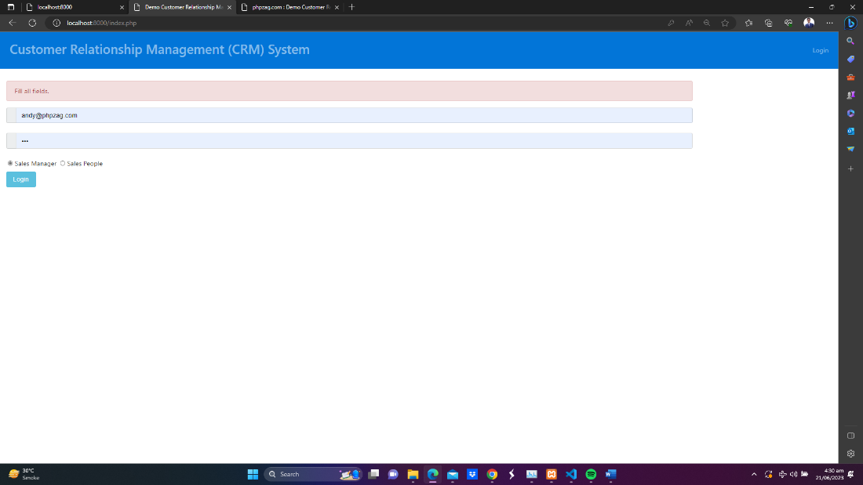

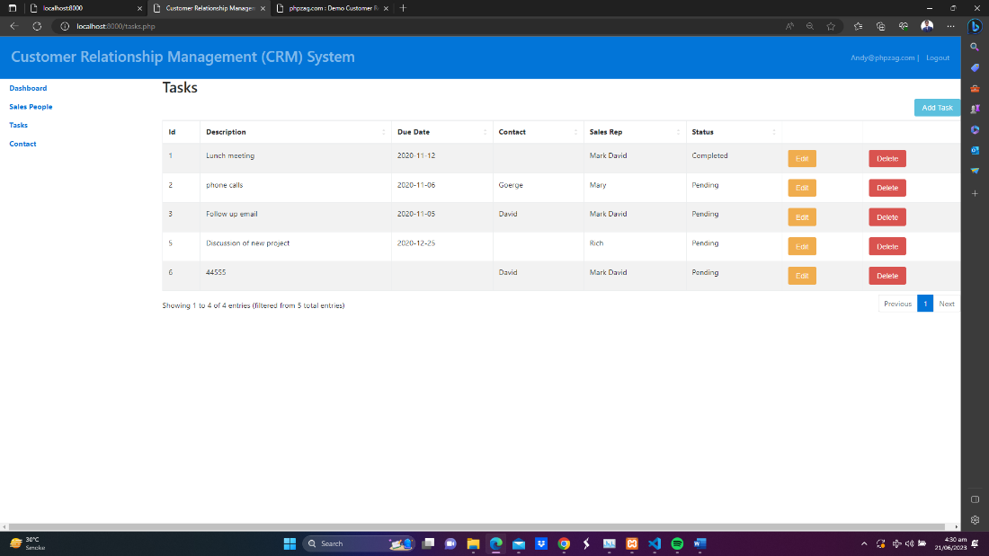

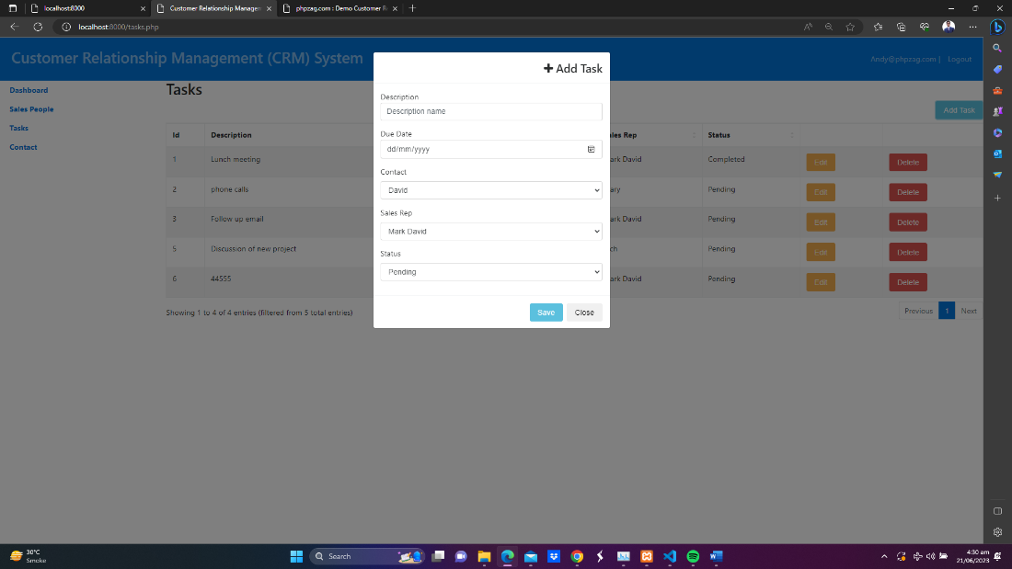

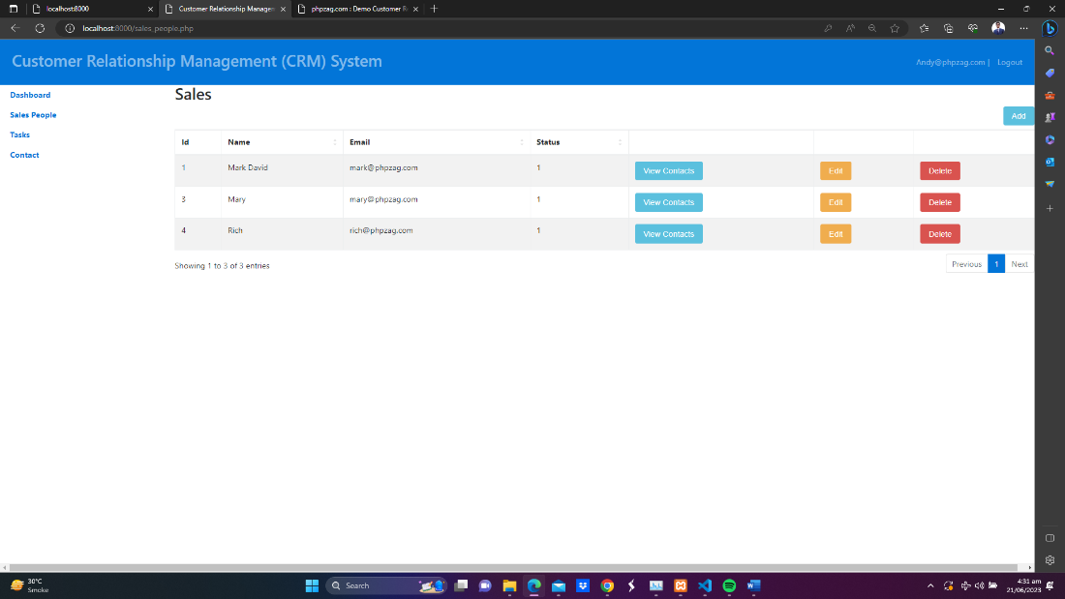

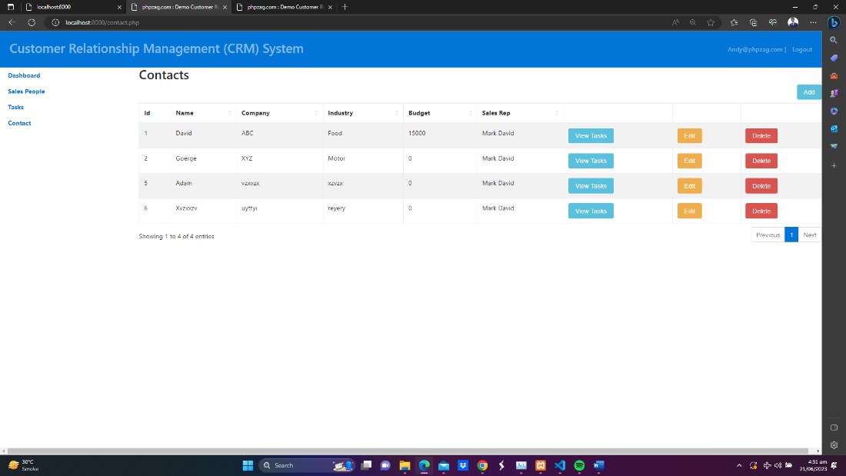

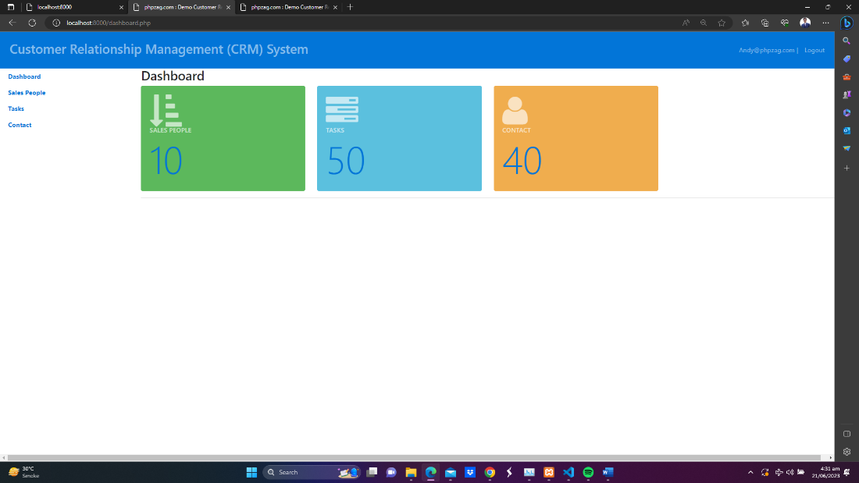

## FOR SALESPERSON

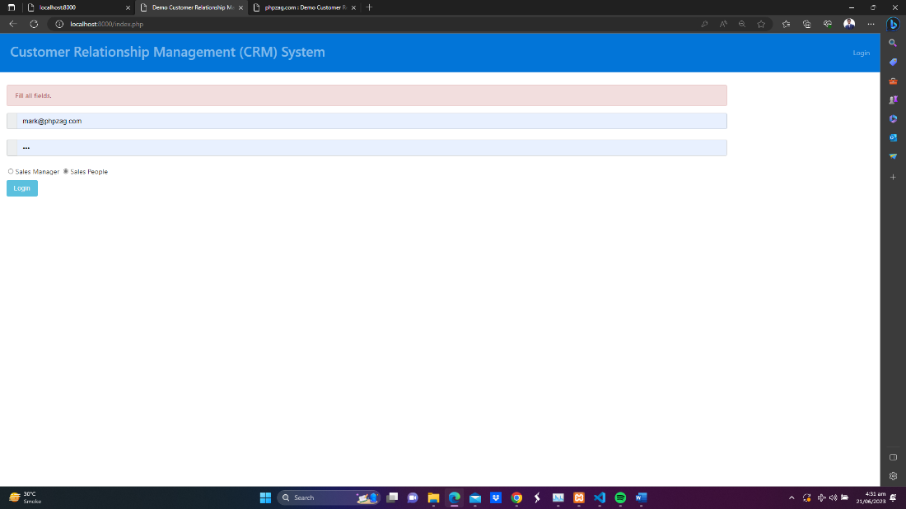

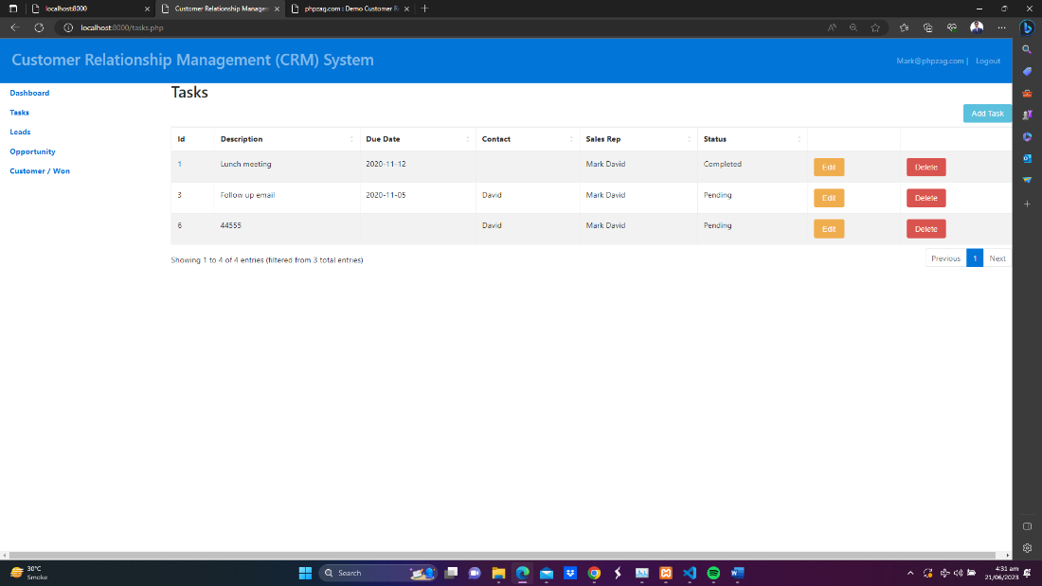

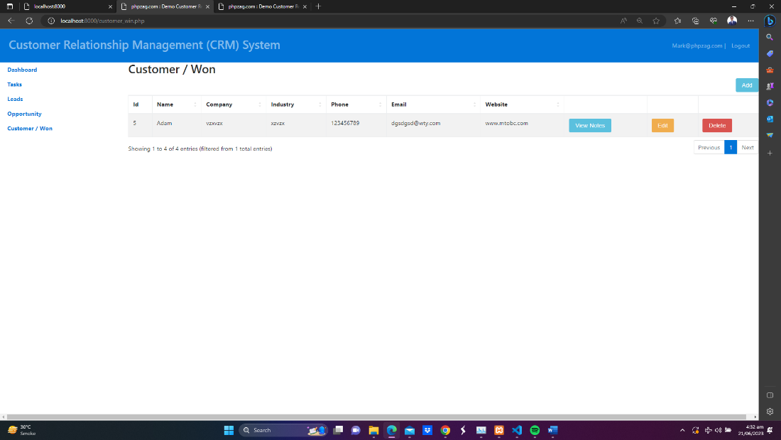

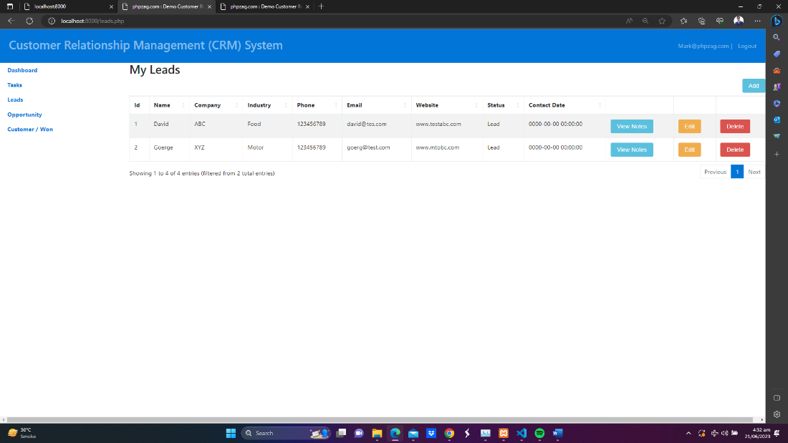

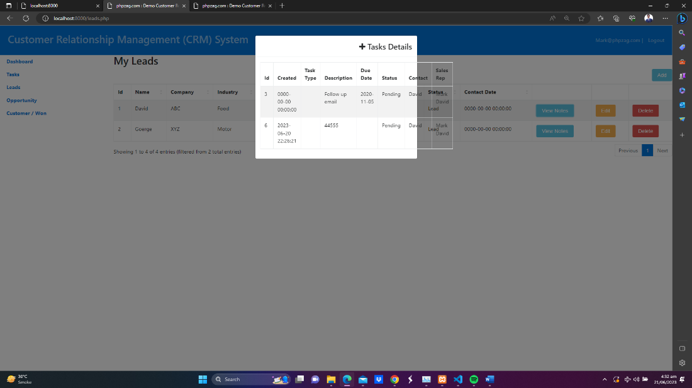

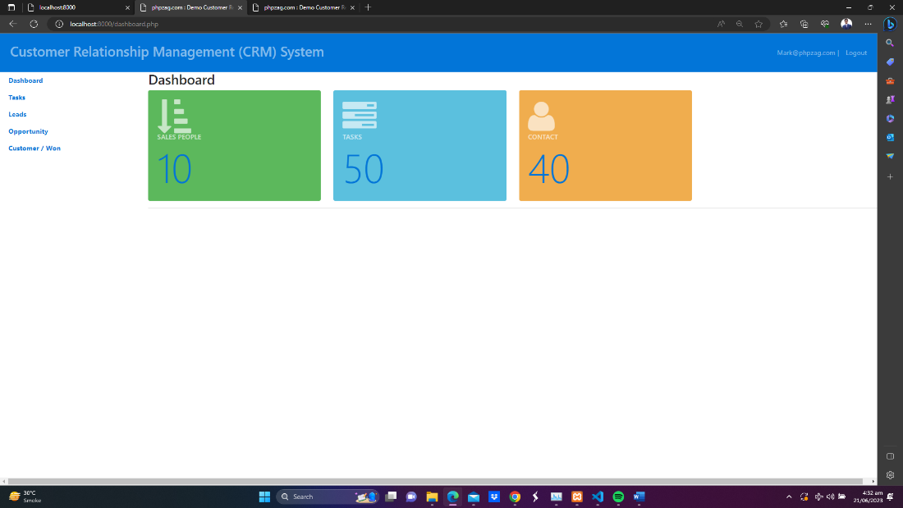

FOR ONLINE EXPERIENCE, PLEASE VISIT THE WEBSITE :-

**http://webassignment.unaux.com/**